Assignment 4 - Q3

Fenglin Chen

06/12/2021

#### Table 1: Proportion of Changes

To study the effect of COVID-19 on sales in each country, the fraction of businesses with increasing, constant, or decreasing sales are counted below. Responses with NA, -9, or -99 were removed from the sample since they do not affect the relative sizes of each group.

|  |  |  |  |  |  |  |  |
| --- | --- | --- | --- | --- | --- | --- | --- |
|  | Italy | Bulgaria | Greece | Hungary | Romania | Poland | Russia |
| % Increase | 7.160 | 6.977 | 16.981 | 10.178 | 13.725 | 5.067 | 5.619 |
| % Same | 19.332 | 23.062 | 13.962 | 39.418 | 25.882 | 40.228 | 23.705 |
| % Decrease | 73.508 | 68.023 | 69.057 | 50.404 | 55.686 | 46.225 | 69.096 |

Table 1 shows that in all countries, a higher proportion of businesses reported a decrease than an increase or constant sales. Therefore, COVID-19 had a negative (but un-equal) impact in all 7 countries.

Italy seems to fare the worst at 73.508% of sampled businesses decreasing, while Poland is the most unchanged at only 46.225% of businesses decreasing.

#### Table 2: Total Change

|  |  |  |  |  |  |  |  |
| --- | --- | --- | --- | --- | --- | --- | --- |
|  | Italy | Bulgaria | Greece | Hungary | Romania | Poland | Russia |
| Total % Increase | 707 | 570 | 2124 | 1242 | 1529 | 846 | 958 |
| Total % Decrease | 16229 | 12968 | 17430 | 9165 | 10090 | 14491 | 28131 |

Across all countries, businesses with increased income saw smaller positive changes than the negative changes seen in businesses with decreased income. The total effect of both factors is shown in Table 2 above, where it is evident that the overall effect is very negative.

#### Figure 1: Individual Changes

The positive and negative changes in each country are shown in the graph below and further demonstrates the point in Table 2.

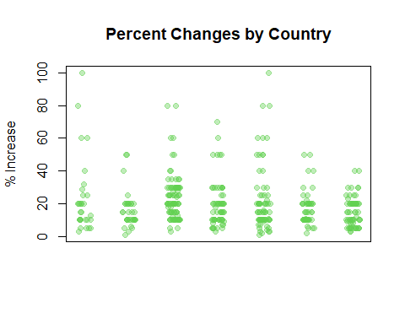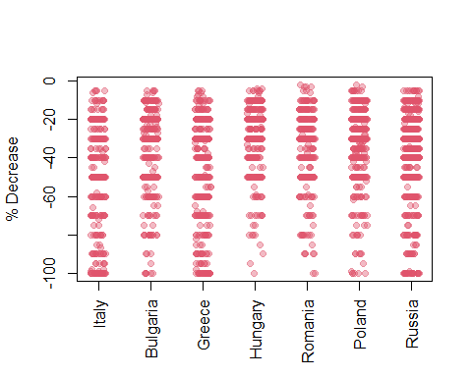

#### Significance Test 1

To compare how similar or different COVID-19 affected pairs of countries, a significance test can be used. A smaller p-value indicates a smaller chance that the results were due to randomness.

Null hypothesis H0: Hungary and Greece have the same proportion of businesses that experienced a decrease in income (Table 1). Alternative hypothesis H1: Their proportions were different.

## [1] 0

A p-value of 0 means that there was no evidence supporting H0, therefore the alternative hypothesis must be true and they have different proportions.

#### Significance Test 2

Another test can be made about the fraction of businesses that experienced an increase (Table 1).

H0: Italy and Poland have the same proportion of positively-affected businesses. H1: Their proportions differ.

## [1] 0.183

The p-value of 0.183 shows that although there is a fair amount of evidence against H0, it is not enough to reject the null hypothesis. It is still likely that the result was due to random chance.

#### Significance Test 3

Lastly, test whether the total percent increase between Bulgaria and Romania are different.

## [1] 0

The p-value of 0 indicates that “H0: Bulgaria and Romania have the same total percent increase” can be rejected.

#### Figure 2: Distribution Plots

The discrepancy measures of randomly mixed sub-populations and the population discrepancy are shown below. In conclusion, the effect of COVID-19 differs between the 7 Eastern European countries.

